PEEBLES GOLF CLUB
Membership Information

The jewel in the Borders golfing crown, Peebles is a Harry Colt designed course and vibrant community club set in a beautiful location. With our recently refurbished modern clubhouse to match, you can experience our renowned hospitality, stunning scenery and family-friendly atmosphere. We have a proud reputation as one of Scotland's leading junior clubs, with a fantastic driving range practice facility and quality service from our two PGA teaching professionals. Peebles really is the perfect place to enjoy your golf and a great club to be a part of…

Benefits of Joining Peebles Golf Club

Clubhouse Access
- A modern, welcoming clubhouse with excellent facilities
- Members bar, lounge and restaurant
- Top class bar and catering service serving breakfast, lunch, dinner, alcoholic beverages and barista hot drink drinks
- Free function hire of the clubhouse for your celebrations

Competition Golf
- Regular competitions and medals for Men (Sat & Wed) and Ladies (Sat & Mon), Juniors (Friday afternoons) with a mix of formats
- Meet fellow members by playing in our various Matchplay, Mixed, Team and Fun events
- Gain an official WHS handicap

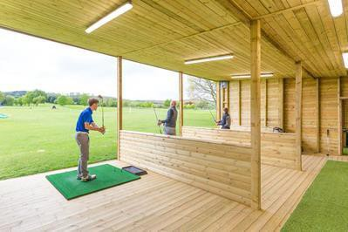
Looking After Our Members
- Fully stocked golf shop
- Two PGA teaching professional: Steve Johnston & Ailsa Murphy
- Office management team providing membership services
- A top-class conditioned course playable all year round
- Covered floodlit driving range, indoor and outdoor bays, PGA swing studio, short game practice area

An Award-Winning Junior Programme
- Thriving junior section with 100+ members
- Junior Academy for primary and secondary age members
- Discounted memberships for families with more than one junior member

Golf When You Want It
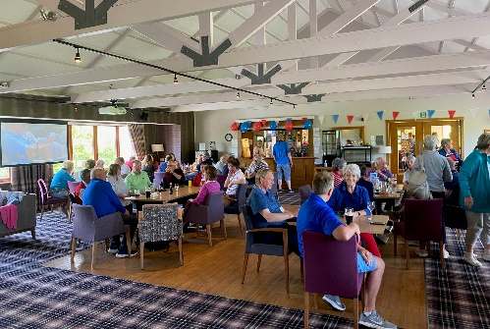
- Whether it’s a quick 9 holes on a Tuesday evening, the Saturday medal or a bounce game with friends, as a member you have the choice of when and how much you play
- Our members APP and online tee booking system makes securing your preferred tee-times easy

Social Time at Peebles GC
- Fabulous catering from the ‘From Scratch Restaurant’ team offering breakfast, lunch, dinner and snacks
- A great selection of social events, from food theme nights and family quiz nights, to live bands and celebration events
- Barista coffee service – lattes, cappuccino, hot chocolate
- Ability to book private social functions for members

Beginner Coaching
For new members and newcomers to the game, PGA professional
Ailsa Murphy offers special group coaching classes, to get you ready
for hitting the course

1892 Club: Peebles Golf Club are a members of a group of clubs who were formed in 1892 offering reciprocal and preferential rates at other courses within the group across the UK.

Come and See Us…
Want to see the club for yourself, come and see us. The clubhouse is open 7 days a week 361 days a year or book an appointment via the office - see the details at the bottom of the application form.

“I joined Peebles a few years ago and it is the friendliest club I have ever been a member of. The course is in a wonderful setting with amazing views and there are a great mix of competitions to play in. I’ve met many new friends through playing here and would recommend joining to anyone…”
“The course is really playable all year round and there is a great selection of competitions to play in all year round too. The social side is great, and the clubhouse is a fantastic place to bring your friends and family, as well as enjoying a lovely pint after your round!

Don’t just take our word for it…

PEEBLES GOLF CLUB
Application Form
Name
Male / Female
Date of Birth
Address
Phone Number
E-mail Address
Current Club (if applicable)
Current Handicap (if applicable) & CDH Number
Previous Club & handicap (if applicable)
How did you find out about us?
(e.g. website, Facebook, press advert, member referral)
Member Introducer’s Name
(If you are introduced by a member they will receive the current incentive reward)

Please complete and return to:
E: secretary@peeblesgolfclub.com  Secretary, Peebles Golf Club, Kirkland Street,  Peebles, EH45 8EU  T: 01721 720197 | For further information please visit:  Website: www.peeblesgolfclub.com  Facebook: facebook.com/PeeblesGC  Twitter: @PeeblesGC  Instagram: @peeblesgolfclub

Payment Options
We offer a variety of payment options for membership including monthly direct debit, debit/credit card, cheque and BACS.

Joining Process
Once you have completed the form attached simply drop it into the club office. Once your membership is processed you will receive an induction pack that details your membership benefits and all the information you need to prepare you an enjoyable experience as a Peebles Golf Club member.

